1-When access abuntu throgh VNC Viewer. Below screen display

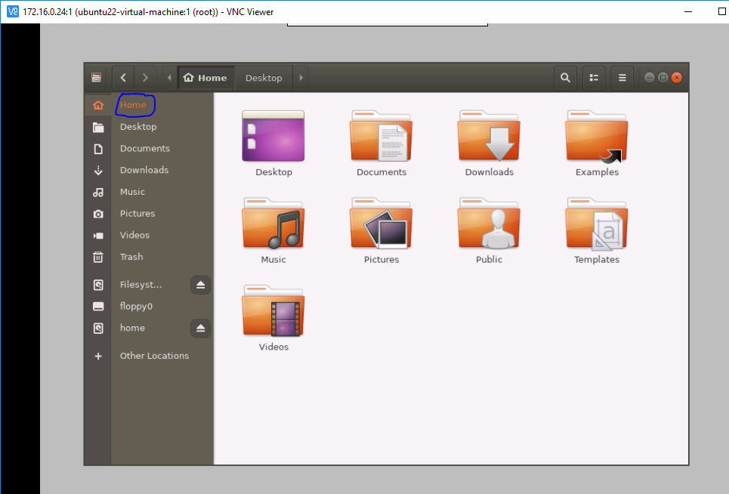

2-Right click on the white background screen and click terminal as shown in below snap.

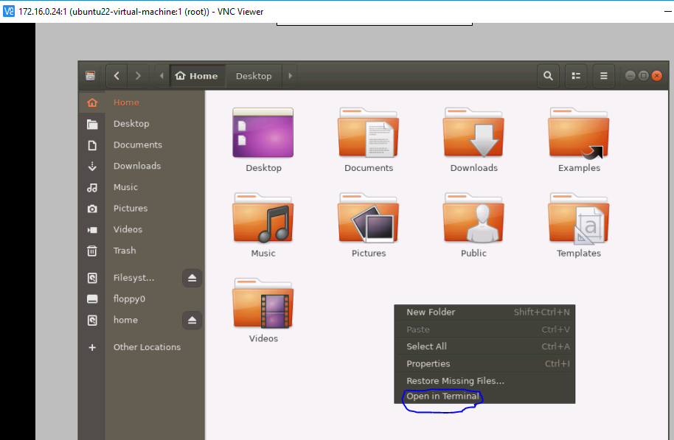

3- type command in the terminal

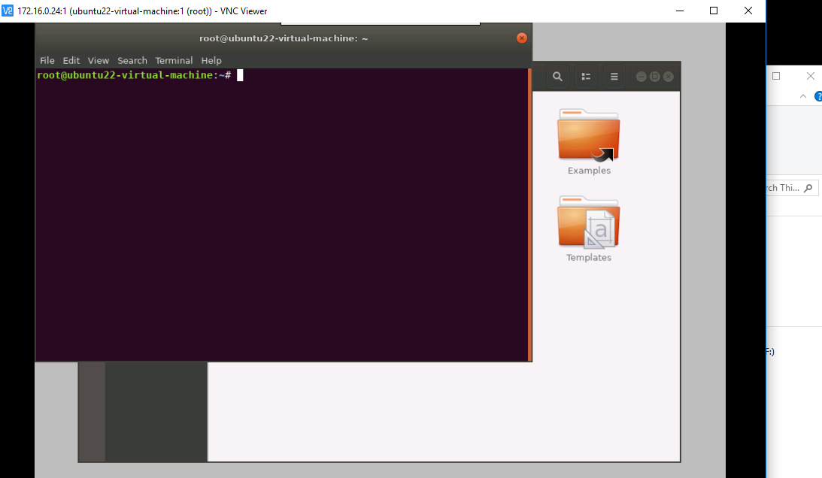

4- for example I want to check IP, I use ifconfig and press enter

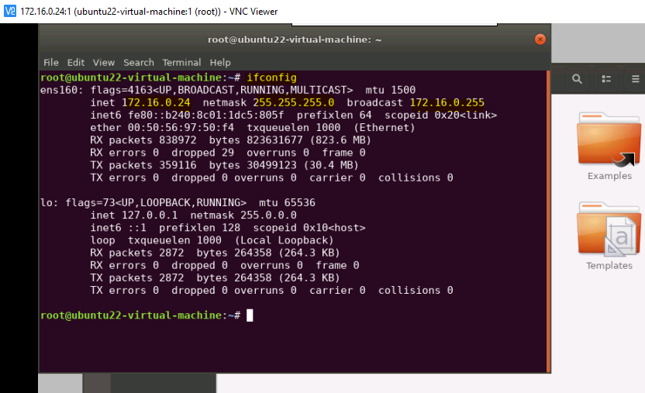

5-You can test the ping 8.8.8.8 for internet connectivity

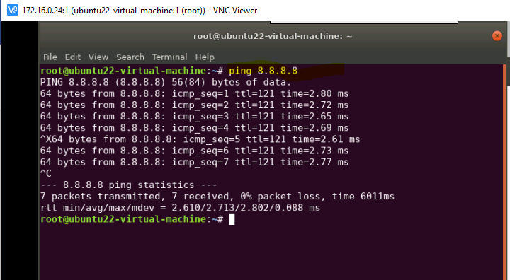

You can cancel the terminal from red cross button

It is user friendly you can easily open any folder.